Version 4.0
October, 2016
English
Neologic – Short Presentation
© NABLA LTD

Introduction
Neologic is integrated system for operational control of business process of small, medium and large companies.
Neologic is designed as a system which can be expanded and adjusted in such a way so that the users of every branch and any type of company get a system, capable of fulfilling their business needs and requirements.
Neologic provides an integrated and easy for use functionality for both commercial, service and manufacturing enterprises .
Similar to the traditional systems, Neologic is focused on automation of the fundamental business processes while providing unified, integrated system instead of series of modules, connected with data transfer between them.

Requirements

Computer configuration and network security

Neologic is capable of working on wide variety of computer configurations and network infrastructure, allowing the users to choose the best setup for their requirements.

Operational system
Neologic works on wide variety of operational systems such as Windows, UNIX and Linux.

Database and software components
Neologic uses Oracle Database. That and all of the other software components that Neologic uses are available for free which saves the users additional costs.

Neologic
The main menu of the program has separate components with different purpose. The next part of the presentation is a short explanation of them.
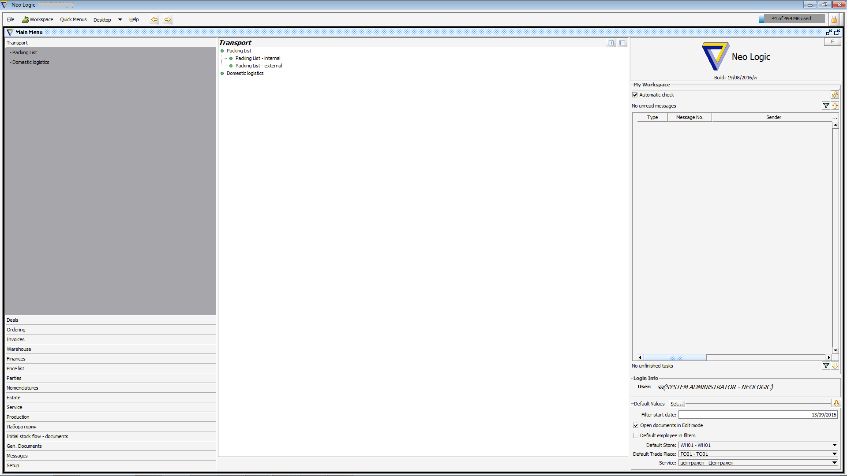

Transport
Transport – Allows the creation of packing lists for both domestic and external transportation which helps tracking and scheduling any kind of shipments and other logistic activities.

Deals
Deals – Serve the creating and processing of complicated deals for deliveries and/or sales that continue in a period of time. It handles multiple parties in a deal together with the people for communication. It handles the management of documentation that originated from the planning, execution and finalization of the deal. It handles the logistical management of the goods and the processes of their customs service. The functionality is closely integrated with the business processes that come with billing, warehouse management and payments.

Ordering
Ordering – Handles the business processes that come with accepting client’s requisitions, offers, delivery of goods, billing and payments. Neologic provides a component “Small sales” which integrates barcode reader and connection with fiscal device. The component is particularly suitable for shops.

Invoices
Invoices – Handles the creation of all kind of trade documents (Invoices, Proforma Invoices, Credit/Debit notes etc) for both purchases and sales, warranty cards, collaborations with suppliers and more. There is a wide variety of available reports that come with sales and purchases.

Warehouse
Warehouse – Handles the warehouse processes. It covers all warehouse operations. Full integration with every business process, goods reserving, sales, purchases, movement of goods, materials and production

Finances
Finances – Handles the creation and management of financial documents connected with payments of the trade documents such as cash payments, bank statements as well as various reports.

Price list
Price list – The program allows the creation of unlimited amount of price lists. The prices in those price lists can be used for setting prices in the sale documents with various settings: eligible clients, periods of activity, amounts etc.

Parties
Parties – ПIt handles the creation and redaction of the clients of the company, their employees and organizational structure, It allows the definition of Groups of Companies when tracking credit limits, takings and obligations.

Nomenclatures
Nomenclatures – It handles the work with production, materials, services and others that are part of the of the business process. Every nomenclature is defined with parameters which allow its participation in every business process.

Service
Service – It serve the whole service activity of the company. It controls the whole “life span” of the service order-accepting the item, execution, registration of the used materials and work, compatibility and interchangeability of the parts and materials, billing and payments.
Including extra protocols for:
- Temporary product
- Revocation of warranty
- Protocol for product substitution
- Product return
- Transfer to another internal service
- Transfer to external service

Production
Production – It serve all of the production processes, production lots, analysis and control over the production. The functionality is closely integrated with the technological card of production and warehouse management of the production and used materials.

Лаборатория(Laboratory)
Laboratory – Defining indicators and standards. Preparation of analysis certificates in the study and control of raw materials, materials and ready production.

Others
Messaging system – It allows transfer of messages from and towards the user inside the system. There is possibility of file attachments and document links in those messages.
Tasks – It allows the definition of tasks, reading the time spend on executing a task and task status.
Export to another software – In negotiating with customers based on their requirements, we can perform customizations and settings used to export information from Neologic to their software, including accounting programs and connection to the online stores.
Others – Multiple companies, multiple currencies, multiple currency rates, multiple languages. Possibility of creating and customization multiple templates for the printing of documents, filters and reports.

